Team Progress Summary
  - Week: 7
  - Participating Group Members:

John Ahn
Jonathan Kim
Demetrius Schank

  - Submission Date:

Group Member Timecards
All instructions and sample information should be deleted before submission

Group Member ()
Week | Date | Start Time | End Time | Total Time | Task | Completion Status
7 | 10/7/25 | 1:00 | 2:15 | 1:15 | Create TPS  Complete notes for understanding code  Screen record demo | 100
 | 10/9/25 |  |  |  | Midterm Demo w Dr. Klein  Take notes | 100

Group Member 2(Jonathan Kim)
Week | Date | Start Time | End Time | Total Time | Task | Completion Status
7 | 10/7/25 | 1:00 | 2:15 | 1:15 | Completed notes for understanding the MATLAB code. | 100%
 | 10/7/25 | 1:00 | 2:15 | 1:15 | Midterm demo preparations | 100%

Group Member 3(Demetrius Schank)
Week | Date | Start Time | End Time | Total Time | Task | Completion Status
7 | 10/7/25 | 9:38 AM | 10:50 AM | 1:12 | Worked on notes regarding coding. | 85%
 |  | 12:35PM | 2:10PM | 1:35 | Completed Notes on Code, Worked on other Midterm Prep (constraints, criteria, standard, etc.) | 100%  25%
 | 10/9/25 | 10:58 AM | 11:28 AM | 0:30 | Midterm Prep | 50%
 |  | 1:00 PM | 2:15 PM | 1:15 | Midterm Prep | 90%
 |  | 3:00 PM | 3:45 PM | 0:45 | Midterm Prep, Midterm Demo | 100% Both
 |  | 6:15 PM | 6:59 PM | 0:44 | Finished my portion of TPS 6 for W7. | 100%

Progress Summary

Planned Goals and Accomplishments
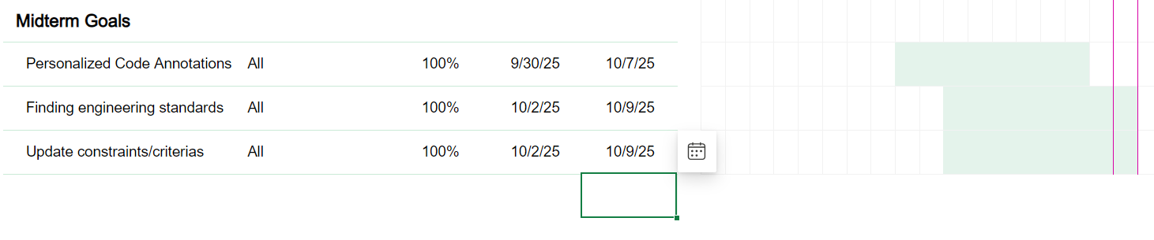

This week, the group successfully completed all the goals outlined in last week’s plan. Everyone worked individually on the “Understanding the Code” assignment by end of day 10/7. Each member was able to clearly explain the code and its function without referring to notes.

Additionally, we updated the constraints and criteria from last semester to reflect the project’s new direction. These revised documents are now finalized and uploaded to the “Midterm Prep and Notes” folder for reference.

Finally, we addressed the task of identifying an engineering standard. Although none directly apply to our project (as noted in the advisor meeting), we documented this finding and explained our reasoning during midterm demonstration. We used matlab style conventions as our engineering standard.

Barriers to the Project
Barries this week were few, as the goals were to mainly prepare for our midterm demonstration. Barries this week were balancing this class with other midterms and other responsibilities. It made it difficult to focus on the project when all of these other assignments, exams, responsibilities, etc. are also taking precedent

Next Weeks Goals
Next week goals are really goals for after we get back from break. Goals with no timeline at the moment are:
- A method to scale the pixels measurements to real-life measurements. Going to be done with drawing a line, then defining the length of the line. This line then acts as a scale for a pixel to meter ratio.
- Create different scripts for additional features, ie velocity, ‘unique frame detection’ script, etc. (should be listed in Meeting Notes from John).
- Create “Fall 2025” Folder legend, detailing exactly what each file/folder is in the Fall 2025 Folder. – Demetrius
- (This is ideal world with excess extra time) Go back and create legend for “Spring 2025” Folder, explaining each file and document in that folder. This will be difficult due to the time that has passed and the overall disorganization of the folder, as there are files from previous iterations of this project in that folder.
Other goals include completing and submitting the Testing Plan document due Thursday 10/23. This was already started due in our midterm prep document (Partially completed on the “Midterm_Rubric_Structured_Notes.docx” document.

Advisor Meeting Notes
When you share this report with your advisor at your weekly meeting, take notes and record them here.

9/8/25
Some setbacks: Still finding standards with the microscopy method
Standards we can use (as listed by Dr. Wynne):
Probably not the blood collecting one
Maybe the video library (NIH) - resolution guidelines
Tools that we can use – Matlab (we already have one for Matlab)
What are the engineering standards for image processing tools?
Can also check IEEE, and ACM
It’s pretty dificult to find the “golden” standards, because we are not really building anything with set standards, but rather recommendations (like the Matlab guidelines)

Upcoming assignments: Testing plan (due Thursday we come back from break)
Look online “What are some testing plans for image recognition tools?”

Structure for presentation with Dr. Klein:
Introductions / Title of project:
Background and Objectives
Methods
Image processing tools from matlab
Where did we get the data? - an online database? Journals?
Demo (brief description):
“this is what we have so far, and we are trying to get to this during this amount of timeline”
Here are some setbacks
Is it working the way we think it should work out? Hurdles?
In a perfect world:
we can capture velocity and deformation, but we’re starting at cell shape at two frames
We work on building this system where we capture video

